**JAVA ADVANCE PROJECT**

Liam Baron – Eduv4813733

In this document, I will be going through what you need for it to run and features about this application

INFORMATION ABOUT THE PROJECT

* Java version in use 1.8 for compiling and running the application but Java 20.0.2 s used as well so that it will be compatible with the Netbeans version I am using which is 19.
* The driver that I am using is mssql-jdbc-12.4.2.jre8.jar.
* With Java ee 7 and Glassfish 5
* SQL Server Management Studio 19 with SQL Server 2019

AN ERD OF THE DATBASE AND ITS TABLES

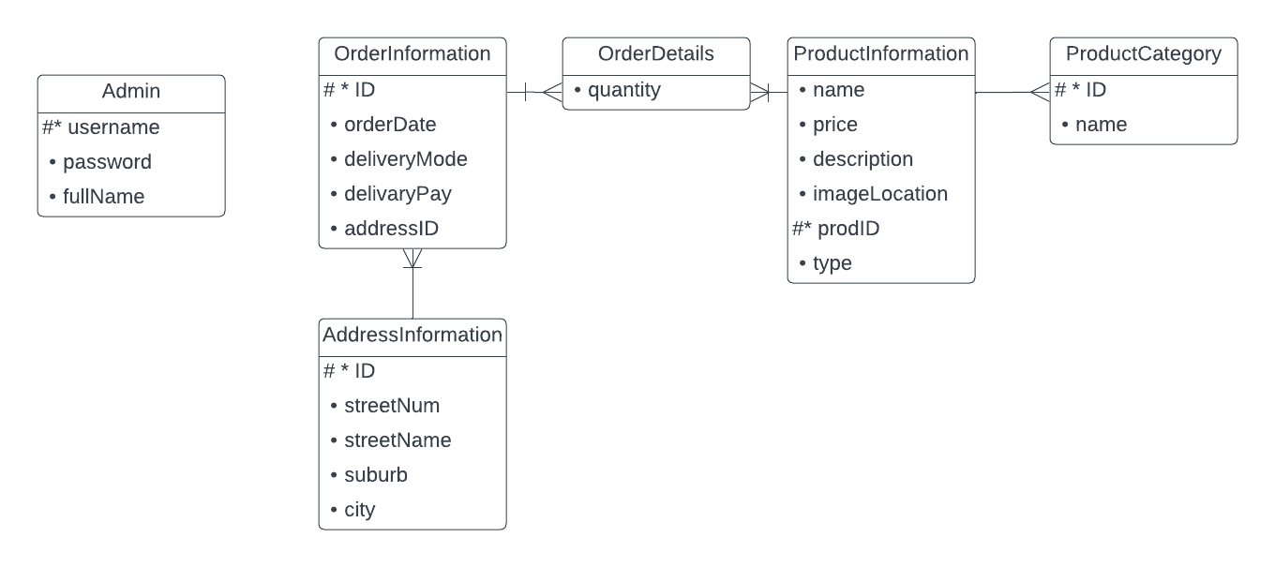

REASONS WHY I USE NETBEANS 19

* Some files were not able to generate properly which was important like the generated sources package that is needed to get access to the web methods.
* It does not generate incomplete code or no code at all.

HOW I FIXED THE CONNECTION FOR THE PROJECT TO WORK

These are what helped me fix it even though each PC is different I would recommend going through these steps incase a problem were to rise.

* I added the the driver into the project using maven dependencies as well as the auth.dll file because I am using Windows Authentication I ran into no problems using this method compared to SQL Server Authentication.
* I Deleted the Sun folder located on “glassfish5\glassfish\modules\endorsed\” I believe you need to have administrator permissions. The reason being that I keep on getting an SSL certificate error though in my previous project I ran into this issue before but I didn’t use an IDE so solving it was different.

ASSUMPTIONS MADE IN THIS PROJECT

* There is only one admin.
* There are only two food types Pizza and Beverage.
* Glassfish5 is already installed on your device.

RUNNING THE PROJECT

* All the required files are in the project but first things first you need to run the Database and table creation sql file and then the Insertion file.
* The project even though created on Netbeans 19 it can still run on 12.6.
* Next you will then open the project in Netbeans and before you run it make sure it is compiling using Java 1.8 for both applications
* Before you run the PizzaStore application you will need to change some dependencies like the java ee and the sql server driver. In the downloads folder will be the sql server driver. To do this you want to go to the PizzaStore application and look for a folder called Dependencies.
* Right click on the mssql-jdbc-12.4.2 driver and select manually install artifact and this is where you will go to the location of the downloaded project and select the driver in the project.
* Finally click install this will install the driver to the project application.
* You first want to run the server on being the PizzaStore application then the client one.

FINDING RESOURCES THAT WAS CREATED FOR THE PROJECT

The location of where the order.txt file is:

* “ClientPizza\target\ClientPizza-1.0-SNAPSHOT\resources\log\orders.txt”

The location of where images are stored when they are uploaded:

* “ClientPizza\target\ClientPizza-1.0-SNAPSHOT\resources\log\images\”

The location of the JavaDocs:

* “ClientPizza\target\site\apidocs\”

A QUICK OVERVIEW OF THE FEATURES OF MY WEBSITE:

